
North Wolds Federation
Spirituality Policy
September 2024


Our inclusive school community puts our Christian values at its core and endeavours to develop all members to be wise, happy and spiritually aware individuals who can achieve their dreams and goals.
Working with our local community, we care for and educate each person, respecting individual differences.
As Jesus welcomed all, so we welcome everyone into our school and strive to send them out prepared to be good citizens in today’s diverse society.
We are preparing for a brighter tomorrow.
Start children off on the way they should go, and even when they are old they will not turn from it. (Proverbs 22:6)
Caring, Respect, Co-operation, Commitment to Achieve, Honesty, Fairness
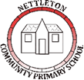
Our inclusive school is at the heart of our small community where all families feel welcome, valued and supported as friends.
Working with our local community children leave us, ready for their next learning adventure, as well-rounded citizens with the skills, knowledge and the confidence to be happy and successful for the rest of their lives.
We nourish their bodies and characters with our school values of respect, cooperation, independence, care, happiness and commitment to achieve.
We ensure they have the armour of our love and guidance to be the best version of themselves and carry that forward with their actions towards others
Caring, Respect, Commitment to Achieve, Co-operation, Happiness, Independence
Policy Approved on : 10/06/2024
Chair of Governors Signature : Approved Via Governor Hub
Policy Review Date : 06/2025

This policy is underpinned by the following aspects of the Market Rasen Church School Vision; inclusive school community, develop all members to be wise, happy and spiritually aware individuals, achieve dreams and goals, working with our local community, care for each person, respecting individual differences, welcoming everybody, preparing for a brighter tomorrow and “Start children off on the way they should go, and even when they are old they will not turn from it. (Proverbs 22:6)

What is Spirituality
Spiritual development is developing a deeper or richer sense of self, other, world and beyond. The ‘beyond’ is very specific to the individual. It may be a God or an abstract such as love, truth, respect, etc.

Spirituality is a powerful force that determines what we are, our self understanding, our outlook on life, others and the world, and as a consequence shapes our behaviour. It forms the basis for successful relationships both in personal life and at work.

In the North Wolds Federation, the spiritual dimension is expressed through the Christian faith and the recognition of the spiritual nature of mankind.

It is our aim that the children’s individual spiritual development should be fostered throughout the curriculum and permeate all strands of school life.

Our staff discussed what spirituality means to them. Responses included:
- Understanding your place in the world (part of the bigger picture)
- Invisible feelings
- Connection to the natural world
- Awe and wonder experiences
- Deep connectiveness in our community for everyone
- Acceptance of self
- Being inquisitive / reflective
- Togetherness and inclusivity
- Can’t see / touch / feel it
- Connecting with something greater than ourselves
- Opportunity to flourish
- Connections – between all aspects of life on Earth and beyond

Spirituality is defined by our staff as:
- Enabling all our children, staff and members of the community to be part of our ever changing, diverse society
- Embarking on a journey of self warmth, reflection and providing our children with the skills they need to achieve their dreams and goals
- Spirituality is fostered in our school by supporting our children to nurture togetherness and inclusivity through shared opportunities to experience and question the wider world.
- To create and share collective and individual experiences that embrace the wonder of the world around us, to reflect on our place in the world and to connect with others in our school and community.

Aims
The aims for spirituality at the North Wolds Federation are:
• To provide a context of faith, security and loving relationships to support each child’s spiritual search.
• To foster the spiritual development of each child, regardless of age, sex, ability or cultural background.
• To foster self-awareness and promote a feeling of self-worth.
• To develop a set of values, principles and beliefs.
• To develop positive human qualities.
• To develop respect and empathy for other people and their beliefs.
• To foster reflection and stillness.
• To foster a sense of meaning, purpose and direction in life.
• To encourage imagination and creativity.
• To develop a sense of awe and wonder at the miracle of creation, life and the natural world.
• To share Christian stories and respond to Christian festivals, rituals and symbols, particularly those from the Anglican tradition.
• To develop hope and resilience and to build a community of hope.

We use the symbols of windows, doors and mirrors to enable the children and adults to explore spirituality through these concepts:
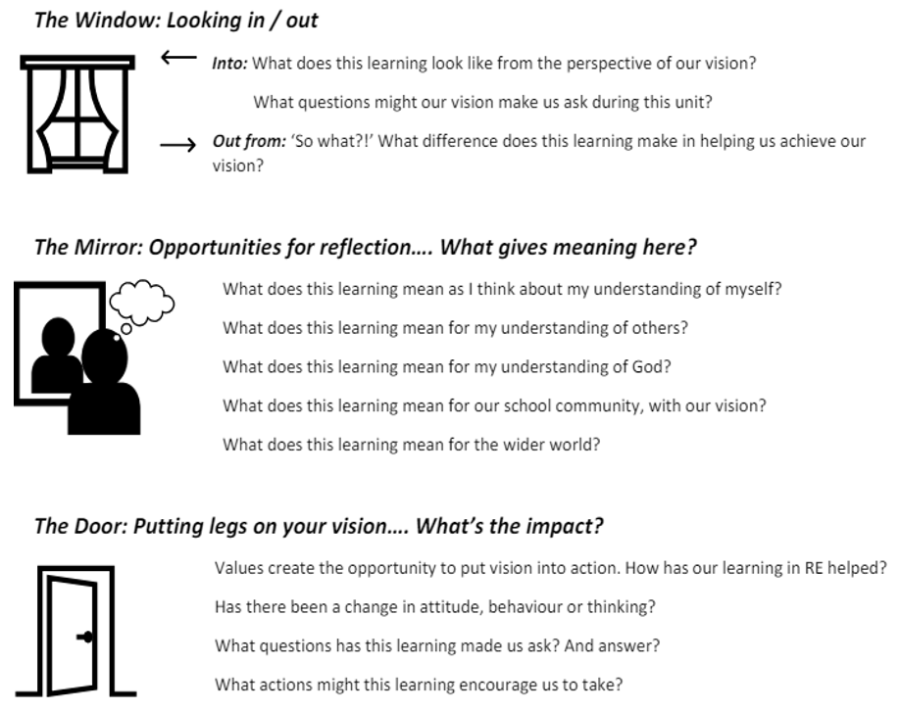

Legal Framework: Links to OFSTED and SIAMS expectations
The OFSTED School Inspection Handbook, November 2019 No. 190017, page 59 & 60, states:
Inspectors will evaluate the effectiveness of the school’s provision for pupils’ spiritual, moral, social and cultural education. This is a broad concept that can be seen across the school’s activities but draws together many of the areas covered by the personal development judgement.
Provision for the spiritual development of pupils includes developing their:
- ability to be reflective about their own beliefs (religious or otherwise) and perspective on life
- knowledge of, and respect for, different people’s faiths, feelings and values
- sense of enjoyment and fascination in learning about themselves, others and the world around them
- use of imagination and creativity in their learning
- willingness to reflect on their experiences.

The SIAMS Evaluation Schedule for Schools and Inspectors, April 2018, includes the question:
- How well does the school support all pupils in their spiritual development, enabling all pupils to flourish? (Strand 2)

Organisation
The spiritual growth of pupils is not only dependent on learning in RE, opportunities for enhancing the spiritual well-being of learners are developed in every aspect of our school life.

We support the whole school community to share this responsibility and to develop the shared language of spirituality. Opportunities are available for all to develop spiritually in our inclusive school community inspired by our vision and lived out through our Christian values.

We have identified specific areas which contribute to the spiritual growth of pupils: Collective Worship, the whole curriculum, including RE and the general ethos of the school within daily life.

Spirituality in Collective Worship
Collective Worship provides the opportunity for our school community to share experiences, ideas and understanding. It is the context in which the language of spirituality, which we use as a school, is regularly and explicitly shared.

Collective Worship provides the opportunity for pupils to become aware of the importance of reflection and how our positive and negative experiences can be formative. It also provides a real sense of being present which are often linked to invitations to pray.

Through daily Collective Worship, children are offered a space and a place for hearing the Christian story. They are offered an understanding of worship by being invited to participate in, or observe, Christian spiritual practices such as: prayer, reading and reflection on the Bible and liturgy and are introduced to different musical traditions.

Opportunities to reflect on the beauty and joy of the world are given, as well as time to reflect and empathise with moments of disappointment or pain. Children are given time to consider their responsibilities to others and to grow in love and service. Time is given for celebration, both for the accomplishments of school members and to mark seasonal Christian festivals and celebrations in the calendars of other faiths. In this way pupils are offered time to be able to contemplate and develop spiritually. Collective Worship is invitational, inspirational and inclusive.

Spirituality in Religious Education
The Church of England’s Statement of Entitlement outlines the aims and expectations for Religious Education in Church of England Schools and guides our school’s approach to RE and spirituality.

Learning activities in RE provide for the needs of all pupils, offering a safe space to explore their own religious, spiritual and/or philosophical ways of seeing, living and thinking, believing and belonging. They provide opportunities to engage in meaningful and informed dialogue with those of all religions and worldviews, linking these to pupils’ ideas of spirituality.

In Religious Education, spirituality will be explored through people, places, things, books, actions and ideas held by religious believers to be holy.
Ultimate questions of meaning and purpose.
Ideas of the divine/questions of God.
Forms of worship.
Music, art and drama expressing beliefs.
Varieties of beliefs, celebrations and rituals.
Ideas of commitment and belonging to groups and institutions.
The idea of mystery and questions with no clear answers.

Maths
Points to consider:
The wonder of number patterns / maths in the natural world
What cannot be measured? For example, love
What cannot be accurately counted? For example, the difference an act of kindness makes.

Reading
Points to consider:
How do you frame questions around a text? For example
What inspired you in this text?
How did a character cope with a challenge in life?
How did the actions of a character surprise you? How do you think you would have responded to that moment?
What do you think makes these words so powerful/beautiful/painful?
Impact of the text – poetry / impressions / context

Writing
Points to consider:
If children are invited to write about things that have profound meaning to them, how is this writing valued? How can it be recognised as having value, rather than simply be reduced to an evaluation of GAPS?

DT
Points to consider:
What motivates designers and their decisions? For example, is it a desire to make money or a desire to help and make improvements to daily life for everyone?

Music
Points to consider:
What style of music ‘invites you to explore the mystery that dances within your soul’
What styles of music have the opposite effect?
How does music encourage creativity, delight, and curiosity?

MFL
Points to consider:
What motivates language learning? For example, buying an ice cream on holiday or welcoming and comforting a stranger in our country?
What does it feel like to genuinely communicate with someone in a new language?

Geography
Points to consider:

Wonder at the diversity of environments and people.
Questions about the care of the environment.
The beliefs behind particular causes and campaigns.
World (economic) development.
Land formation.
Empathy with people from other parts of the world.
Discovering that different physical regions do not provide the same opportunities.
What options/opportunities are there to respond and take responsibility in a challenging world?

History
Points to consider:

Being in touch with past people, things and ideas.
Being part of history.
Handling artefacts.
Influential events and people.
The commitment of significant people in history.
War and peace.
Interpretation in history.
The nature and importance of invention and exploration.
Empathy with people from other times in history.

PE
Points to consider:

How do you celebrate a new skill? How does it feel to be proud of your whole self?
What does it feel like to be completely focused on a task or challenge?
How do you recognise the delight in movement, connectedness, and creativity?
Encourage the awareness of one’s own strength and limitations.
Recognise/celebrate equality, freedom, respect and trust.

Science
Points to consider:

Delight in discovering how things work.
Opportunities to linger longer on the wonder!
What questions cannot be answered by science?

Art
Points to consider:

How does art invite you to explore the mystery that dances within your soul?
What are the stories behind the artists you study?
How do you celebrate and respect different responses to art?

PSHE & RSE
Points to consider:

As you explore topics such as relationships, feelings & attitudes, keeping safe and ‘your body’, think about how can the honesty and sensitivity needed to explore these topics gently reflect the language of spirituality already used throughout the school?

All Subjects
Points to consider:

How do you celebrate the achievement and break-throughs of success?
How do you support the feelings of difficulty and frustrations?
How do you maximise the everyday moment of concentration and being in the present, creating a sense of calm and completeness?

Spirituality within the Ethos of the Daily Life of the School
We view spiritual growth as becoming more and more aware of one’s natural, innate spirituality. These opportunities happen throughout each and every day as children deal with delight, disappointment and the chance to be present with themselves.
For this reason, every member of the school community is familiar with the school’s shared language of spirituality and will respond to pupils appropriately.

In Collective Worship:
Opportunities for reflection are planned into the worship.
Stillness.
Personal and collective beliefs are respected.
Sharing and celebrating common beliefs.
Celebrating success.
Sharing sorrows.
Common activities such as singing, listening, laughing, praying, reflecting on a theme.
Remembering and celebrating the lives of people of spiritual significance.
Emphasising common purpose and values.

In Extra-Curricular Activities:
Visits to places of beauty, interest and challenge.
Opportunities to admire and wonder at the natural environment and human creative efforts.
Working out personal relationships in unusual and challenging situations.

In order to facilitate spiritual development the organisation of the school and the environment for learning are such that:
Everyone involved in the life of the school is valued and seen to be valued.
Policies and ensuing practices are clearly seen to reflect the worth of individuals.
Behaviour and people management policies and practices are collectively arrived at and discussed regularly.
All adults recognise the need to set good examples of mutual respect and considerate behaviour.
The quality and nature of the displays reflect the value placed on pupils and staff.
Aesthetic awareness is encouraged.
The atmosphere of the school welcomes differences in beliefs and values, and invites strangers and visitors to belong.
The achievements, successes and efforts of everyone are recognised and celebrated.

Recording, Monitoring and Evaluation
The Curriculum and Community Committee review the policy and consider any views expressed in order to make any changes or recommendations. Recommendations are fed back to the full governing body and are then actioned as appropriate.
Governors ensure that this policy is fully implemented and that practice is consistent with the school’s Christian vision, in line with the school’s monitoring policy and schedule for governors.

Staff Development and Training
We ensure that all staff receive appropriate training and opportunities for professional development, both as individuals and as groups or teams. ECTs and staff who are new to the federation will receive training and support from the staff member identified as leading on spirituality

